Summary of Measures to be used in the Vulnerability component of GAIN.

The GAIN will follow a consistent structure based on the best of published thinking on the topic, the IPCC Review process, and guidance received from the Council of Scientists and the Advisory Board.

The basic structure will focus on an initial set of ‘sectors’ (Water, Food, Health with the eventual inclusion of Coastal, Infrastructure (or Transport) and Energy). Within each of the sectors vulnerability will be represented by three components describing Exposure, Sensitivity and the Capacity to cope/adapt. The Vulnerability axis should represent the vulnerability and adaptive capacity that is largely in the domain of communities and/or national governments. Adaptive capacities that may realistically be influenced by the private sector should usually be in the Readiness Axis.

Based on the May 2011 Meetings, the following criteria were used in selecting the measures for inclusion in the GAIN:

1. Meet user needs and are transparent and conceptually clear.
2. Consistent with current knowledge / best practice.
3. Composed of a select set of variables with the selection based on a logical structure (e.g. sectors by Exposure – Sensitivity – Capacity as described above).
4. Uses data that are accessible, quality checked, and comprehensive in national coverage.
5. Time series are available wherever possible so that previous performance can be tracked. The measures should be actionable (i.e. they can be influenced by actions and leading to measurable changes within a few years.
6. Potentially scalable (from national to regional and local).
7. They should not directly incorporate broad socio-economic measures, such as GDP/capita, HDI etc, but instead focus on variables that are directly representative of the sector and the components of vulnerability.
8. Selection of measures should be guided by existing relevant indices and the GAIN outcome compared with those indices.

The working model is as follows…

For each of the sectors (water, food, health) two streams of measures are incorporated; one describing essentially quantitative measures (amount of water, how much is used, how many have access) and the other essentially quality measures (exposure to poor quality water, impacts of poor water on people, access to quality management measures). The selection will always be a subjective exercise, but some greater objectivity is introduced by following the above guidelines and this structure. Numerous variables (c. 20 different measures for water alone) have been considered and tested against the guidelines in making the selection.

|  |  |  |  |  |
| --- | --- | --- | --- | --- |
| Sector |  | Exposure | Sensitivity | Capacity |
| Water | Quant | **Projected change in precipitation (%).** Gross measure of threat to water resource – change in run-off would be better but not available currently in a comprehensive and authorative data set. | **% internal water extracted for all uses.** Indication of how much of the nationally controllable resource is already being used. | **% population with access to improved water supply.** High % indicates capacity to deliver water to the population and hence lower vulnerability. |
|  | Qual | **Projected change in temperature** (needs scaling). Water quality issues rise in warmer conditions as disease growth & spread increases; less water for sanitation etc. {Also brings temperature into the axis} | **Mortality among under 5 yr-olds due to water borne diseases**. Measure of current extent of impacts due to poor water quality (and to a lesser extent quantity). | **% population with access to improved sanitation**. As above. |
| Food | Quant | **Projected change in agricultural (cereal?) yield** (cf Wheeler) | **% population in rural sector**. These are most sensitive to impacts either through direct food production or loss of livelihood. | **Recent rate of yield increase as ratio of rate of population increase.** If yield increase is not keeping up with population then capacity poor. {What to do for countries with no cereal production? Use overall agricultural productivity?} |
|  | Qual | **Calorie deficit**. If a country is already in deficit then exposed to further shocks. | **% GDP in food imports**. {This could be swapped with exposure variable but the effect on the final index would not be changed.} Score high % as high sensitivity although there could be an argument for the opposite. | **% malnourished children**. Can this be done as “compared with the expected number for the calorie deficit” or “with GDP/cap”? |
| Health | Quant | **Estimated impact of current CC on DALYs**. Will have to use regional estimates for blocks of countries. {I have them} | **Doctor & Nurses per cap**. Attempt to measure on-the-ground delivery of health services. {How does this relate to hospital beds per cap? – Not very strongly at a first look.} | **Longevity**. Better longevity implies better capacity either through medical services or through community practices. |
|  | Qual | **% deaths dues to communicable diseases malnutrition etc** - problem: good reporting but only for 2002 – but it is an exposure snapshot so ok. {Shows exposure to disease / morbidity environment} | ??? Can we look for variation in mortality / morbidity rates as an example of sensitivity to environment? | **Mortality rate of under 5 year olds**. Can this be estimated compared with a broader national health index to determine failure to deliver to young children?  Probably replace with maternal mortality as child mortality is already in water measures. |
| Coastal | Quant | **% land below 5 m.** This is the zone that is subject to threats from SLR and storms. | **% Population in the zone below 5m.** Sensitivity of both people and to a large extent infrastructure. | $GDP/Area??? As in GAIN 0.5 |
| {Maybe have only 1 line of variables for the three infrastructure indicators – so omit this row} | Qual | **Storm frequency** – probably estimated from CRED events data and corrected for length of coastline | **Area of coastal wetland as % of total land**. Coastal wetlands are usually important buffers against storms and important zones for fishing etc. There will be reporting problems with this – also essentially unchanging / non-actionable. | ??? |
| Transport/infrastructure | Quant | **Count of floods and possibly storms (CRED)**. But how to scale this? By land area or by population? | **% of formed and sealed roads of total roads**. | **Ratio of road density to population density**. Low value implies low capacity to deliver. {Needs to be explored} |
|  | Qual |  |  |  |
| Energy | Quant | **% energy derived from either imports or hydro**. As both could be vulnerable under CC. | **Mean energy use per capita.** Sensitivity decreases as a basic level is approached – then what? – plateau or does sensitivity rise again? (WPI uses a ‘quadratic’ measure.) | **% population with access to reliable energy**. Measure of the capacity to deliver until now. |
|  | Qual |  |  |  |

Discussion of the water measures

|  |  |  |  |  |
| --- | --- | --- | --- | --- |
| Sector |  | Exposure | Sensitivity | Capacity |
| Water  See Box 1 for the relationship between the GAIN and the Water Povert Index (WPI) | Quant  **  ** | **Projected change in precipitation (%).** **[PPT% ⬆]** Gross measure of threat to water. This is the commonly used indicator in both the scientific and response communities. However it is not a very effective measure as it does not take increased evaporative demand into account nor changes in the intensity and seasonality of the rainfall. It might eventually be replaced by a more integrating measure such as run-off or even precipitation minus evapotranspiration. The use of a single measure for an entire country is not very valid, especially for large countries where there are large gradients across the country.  **Issues :** An increase in PPT% is taken to indicate reduced vulnerability. However, this might be misleading for dry countries where a large % increase does not imply a large absolute increase in rainfall or in rainfall effectiveness. The increased rain may come in flooding events. Similarly increased PPT% for already wet countries probably provides little useful additional water and may add to flood loads. There appears to be no objective way to correct for these problems but a subjective correction is suggested below.  It can also be argued that PPT% is is a reasonable approximation – for countries with low current precipitation an increase will be disruptive especially if flood frequency increases; for high precipitation countries additional precipitation is also disruptive. There is a range in the middle where additional rainfall might be beneficial but it is hard to adjust for this. Note however, that this is partially taken up in the AG WHEELER.  **Scaling :** The base value is taken to be no change and the index is scaled so that the most negative countries score -1 and the most positive +0.5. This partially accounts for the issues discussed in the previous paragraph.  **Cross Correlation :** Very low  **Reporting & Time Series :** All countries and a single measure only as it is a projection.  **Actionable :** Only via mitigation of GHG emissions.  **Private Sector Messages** **:** None {This is a mitigation issue. Obviously the private sector can play a role there but that is not the purpose of this index.}  **Public Sector Messages :** Actionable through mitigation.  **Alternate or related measures : See comment on run-off above.**  **Summary :** Acceptable for now, but seek eventually to update with a better measure of water impacts. | **% internal water extracted for all uses. [IWE% ⬆]** An indication of how much of the nationally available water resource (originating internally or externally such as from inflowing rivers) is already being used. In the Index a high % extraction is taken as an indicator of vulnerability.  **Issues:** Some countries (especially arid) use well over 100% of their internal water as it is either supplemented by desalination for example. These are capped to 100%.  **Scaling :** The base value is taken as 0% (=0) and 100% (=1).  **Cross Correlation :** Capped variable has low correlation with both GDP/Cap or HDI (r2 < 5%) with or without cap. It is in fact little correlated with most other measures.  **Reporting & Time Series :** Data is reported to FAO at 5 yearly intervals. About 40% compliance since 1990 with enough to detect trends in about half the countries.  **Actionable :** Water use includes domestic, industrial and agricultural of which agricultural water use is the dominant water use in most countries. Thus, this is more a measure of the threat to agriculture than the threat to domestic or industrial use.  **Private Sector messages :** This is a comprehensive measure whose value is determined by many different actions and policies. However, many of these actions are appropriate for private sector engagement ranging from water efficiency measures and recycling to desalination.  **Public Sector Messages :** Similar to those described above. Many opportunities for PPPs.  **Alternate or related measures** : Could exclude external water, but this leads to the anomaly of countries such as Zambia, with major river systems flowing through them, show as very water scare. Zambia uses only 2% of its total available water, but this greatly exceeds the amount of internally generated water. Could also include the volume of dam storage to give some idea of buffering capacity.  **Summary :** Solid measure by most criteria and one used in other indices. The main issue is whether it truly does reflect vulnerability. | **% population with access to improved water supply.** [PIW% **⬇**]High % indicates capacity to deliver water to the population and hence lower vulnerability.  **Issues :** Commonly used indicator. However, it saturates very quickly with most countries with a GDP/cap of >$5000 having close to 100% coverage  **Scaling :** Scale 0% as vulnerability of 1 and 100% as 0 vulnerability.  **Cross Correlation :** Highly correlated with HDI (r2 = 65%) and with GDP/cap (r2 = 25% and r2 = 50% with Ln(GDP/cap)). It is also correlated with PIS%.  **Reporting & Time series :**  **Actionable :** Directly actionable although many countries have already reached the highest score.  **Private Sector messages :** An activity with many opportunities for private sector engagement, especially through PPPs.  **Public Sector Messages :**    **Alternate or related measures :**  **Summary :** Good indicator and commonly used in other indicators. |
|  | Qual | **Projected change in temperature** (TMP% **⬆**). Water quality issues rise in warmer conditions causing disease growth & spread; less water for sanitation etc.  **Issues :** This brings the most commonly used climate change indicator into the index. The use of a single measure for an entire country is not very valid, especially for large countries where there are large gradients across the country.  **Scaling :** The base value is taken to be no change and the index is scaled so that the most positive temperature increases (5.5C) score +1 and the lowest (1.5C) score 0.  **Cross Correlation :** Very low  **Reporting & Time Series :** All countries and a single measure.  **Actionable :** Only via mitigation of GHG emissions.  **Private Sector Messages** **:** None {This is a mitigation issue. Obviously the private sector can play a role there but that is not the purpose of this index.}  **Public Sector Messages :** Actionable through mitigation.  **Alternate or related measures :** No obvious alternatives.  **Summary :** A core measure of projected climate change and used as the basis of many projections, indicators etc. | **Existing incidence of water borne diseases (WBD ⬆)**. Measured as “Water, sanitation & hygiene deaths per 100'000 children<5 yr” to capture the effects on the most sensitive portion of the population.  **Issues :** There are similar data for all people affected but we have chosen to focus on children as they bear the bulk of the burden. There is obviously an overlap with health measures, but this reflects the strong links between vulnerability arising within the water and health sectors.  **Scaling :** The base values are taken to be no incidence (scoring 0) and 1500 incidences per 100,000 children per year, which will result in a small group of countries scoring close to 1.  **Cross Correlation :** Correlates with r2 of 50% to 60% with PIW% and PIS%. But only 35% with ln(GDP/cap).  **Reporting & Time Series :**  **Actionable :** Directly actionable with many countries having room for improvement. Overall improvement in PIW% and PIS% would improve WBD but there also a range of health related actions available.  **Private Sector Messages** **:** Opportunities for the private sector through a variety of clean water and health interventions. Probably a role for local SMEs in providing improved services to emerging cash economy farmers and middle class.  **Public Sector Messages :**  **Alternate or related measures** : A similar measure is available for the whole population. However, children under 5 account for the largest portion of deaths.  **Summary :** | **% population with access to improved sanitation [PIS% ⬇]**. High % indicates capacity to deliver sanitation and quality water to the population and hence lower vulnerability.  **Issues :** Commonly used indicator. However, it saturates quickly, although slightly slower than PIW%, with most countries with a GDP/cap of >$12000 having close to 100% coverage  **Scaling :** Scale 0% as vulnerability of 1 and 100% as 0 vulnerability.  **Cross Correlation :** Highly correlated with HDI (r2 = 75%) and with GDP/cap (r2 = 35% and r2 = 50% with Ln(GDP/cap)). It is also correlated with PIS% (r2 = 60%) but there is still significant scatter among countries with low values of either variable.  **Reporting & Time Series :**  **Actionable :** Directly actionable although many countries have already reached the highest score.  **Private Sector Messages** **:** An activity with opportunities for private sector engagement, especially through PPPs. More difficult to achieve payments for service than for actions relating to PIW%.  **Public Sector Messages :**  **Alternate or related measures :**  **Summary :** Good indicator despite its high correlation with PIW%. There are differences between countries on the low end of both measures. |

**Results for the Water Sector.** Full data are available for 147 UN member countries (out of 192) with many Small Island States having missing data. This can probably be improved with additional searches for missing data. The time series analyses are not yet complete.

|  |  |  |  |  |  |
| --- | --- | --- | --- | --- | --- |
| **Most vulnerable** | | **Median Set** | | **Least Vulnerable** | |
| Niger | 0.35 | China | 0.71 | Argentina | 0.85 |
| Mauritania | 0.37 | Uganda | 0.71 | Costa Rica | 0.85 |
| Afghanistan | 0.40 | Cameroon | 0.71 | Ecuador | 0.86 |
| Iraq | 0.45 | United Arab Emirates | 0.72 | United Kingdom | 0.86 |
| Somalia | 0.46 | Malta | 0.72 | Iceland | 0.87 |
| Azerbaijan | 0.47 | South Africa | 0.72 | Chile | 0.87 |
| Sierra Leone | 0.52 | Sao Tome and Principe | 0.73 | Malaysia | 0.88 |
| Sudan | 0.53 | Barbados | 0.73 | Brunei Darussalam | 0.90 |
| Turkmenistan | 0.54 | Djibouti | 0.73 | Uruguay | 0.92 |
| Madagascar | 0.55 | Bulgaria | 0.73 | New Zealand | 0.92 |

A number of pairwise comparisons were done during the selection process and this will be a feature of the final software and web presentation of GAIN.

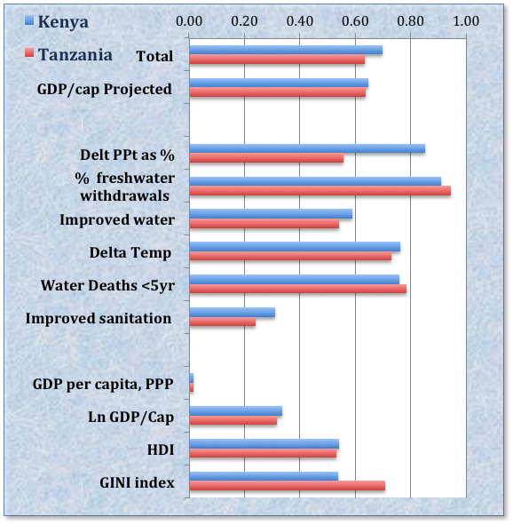

Many poorer countries argue that many indices simply double penalize them by either directly including GDP/capita in the formulation of the index or by including it indirectly through highly correlated variables. In some circumstances this works against the poorest by categorizing them as too poor/weak etc for effective action and in others against middle income countries by amplifying the effects of increasing GDP/cap and directing support away from them to early in their development process. It is inevitable that there will be a correlation between high vulnerability and low GDP/cap and this is the case for the water sector in GAIN. However, it is relative low (r2 = 36% with log[GDP/cap]) compared with either the WPI (55%) or the HDI (88%), so it does appear to be gathering components of sector relevant information different from these other indices.

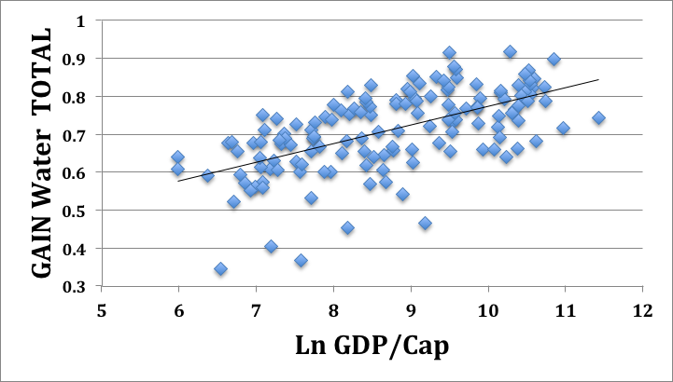

**Box 1. GAIN and the Water Poverty Index (WPI)**

|  |  |
| --- | --- |
| **WPI Component Data Used** | **GAIN** |
| **Resources** |  |
| 1. • internal Freshwater Flows | Indirectly included in the measure of water withdrawal as a percent of internal + external inflows |
| 1. • external Inflows |
| 1. • population | Not a measure of water resources |
|  |  |
| **Access** |  |
| 1. • % population with access to clean water | Included |
| 1. • % population with access to sanitation | Included |
| 1. • % population with access to irrigation adjusted by per capita water resources | Not included but considered for the Agriculture / Food measures. Data is poorly reported. |
|  |  |
| **Capacity** |  |
| 1. • ppp per capita income | Not a measure of water resources |
| 1. • under-five mortality rates | Similar, but more specific, measure used – viz “Under 5 year-old Mortality due to water borne diseases”. The two measure are highly correlated, but the GAIN measure is more directly water related. |
| 1. • education enrolment rates | Not a measure of water resources |
| 1. • Gini coefficients of income distribution | Not a measure of water resources |
|  |  |
| **Use** |  |
| 1. • domestic water use in litres per day | Considered, but the more important measure is captured in % population with access to clean water |
| 1. • share of water use by industry and agriculture adjusted by the sector’s share of GDP | Considered under agriculture, but included indirectly in the GAIN measure of water withdrawal as this is usually dominated by agriculture |
|  |  |
| **Environment** | Not considered at this point in the GAIN |
| 1. • water quality |  |
| 1. • water stress (pollution) |  |
| 1. • environmental regulation and management |  |
| 1. • informational capacity |  |
| 1. • biodiversity based on threatened species |  |

The WPI attempts to cover a wider domain than the water component of the GAIN with 17 measures compared to 6 for GAIN and the WPI includes environment and water pollution measures that are not considered in this component of GAIN. The WPI also includes socio-economic measures (e.g. GDP per capita, GNI etc) that are not considered for explicit inclusion in GAIN.

Nevertheless, the two indicators are highly correlated (r2 = 45%), but with no clear systematic differences. Some of the difference may arise from changes in reporting (the WPI data were gathered almost a decade ago) and from the inclusion of the climate change projections for temperature and precipitation in the GAIN which reflects the different purposes of the two indices. This is borne out by removing the climate projection component from the GAIN index and the correlation with the WPI rises to r2 = 60%.

